Kilmartin Primary School and ELC

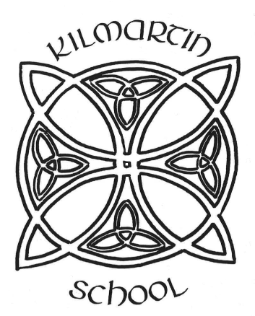

Contents:
- Education Service Plan Priorities – OCTF Key Priority Areas
- Overview of Establishment 3 Year Cycle of Improvement Plan Priorities
- Strategic Improvement Planning for Establishment
- Operational Improvement Planning (Action Plan) for Establishment
- Establishment Maintenance Improvement Planning

Our Children Their Future – Thriving Together
Key Priority Areas
BEST START FOR LEARNERS | AMBITIOUS LEARNERS | NURTURED  LEARNERS | CONNECTED  LEARNERS | LIFELONG LEARNERS
Every learner has inspiring learning environments that build curiosity, confidence and the love of learning. | Every learner is supported and challenged to aim for their best. | Every learner has the opportunity to thrive in a safe, happy and supportive space. | Every learner is active in their local and global community. | Every learner benefits from opportunities to seek knowledge, value challenge, welcome change and keep learning throughout life.

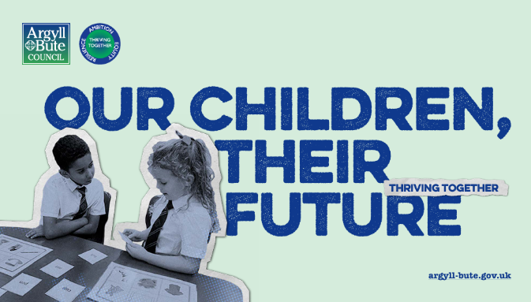
Education Service Plan Priorities





Building collaborative leadership and evidence-informed practice to ensure effective self-evaluation, accountability and continuous improvement.

Enhancing learner pathways, achievement opportunities and partnerships to support skills development and sustained positive destinations.

Strengthening inclusive practice, early intervention and targeted support to reduce the poverty-related attainment gap and improve wellbeing, attendance and engagement

Improving the quality and consistency of curriculum design, learning, teaching and assessment to secure strong literacy, numeracy and equitable outcomes for all learners.

Overview of Establishment 3 Year Cycle of Improvement Plan Priorities |  |  |  |  | Session: 2026-2027
National Improvement Priorities | HGIOS 4 |  | Early Learning and Childcare Quality Indicators |  | Argyll and Bute Education Key Priorities
- Placing the human rights and needs of every child and young person at the centre of education.  - Improvement in children and young people’s health and wellbeing.  - Closing the attainment gap between the most and least disadvantaged children and young people  - Improvement in skills and sustained, positive school-leaver destinations for all young people.  - Improvement in achievement, particularly in literacy and numeracy. | 1.1 Self Evaluation for self-improvement  1.2 Leadership for learning  1.3 Leadership of change  1.4 Leadership and management of staff  1.5 Management of resources to promote  equity  2.1 Safeguarding and child protection  2.2 Curriculum  2.3 Learning teaching and assessment  2.4 Personalised support  2.5 Family learning  2.6 Transitions  2.7 Partnership  3.1 Ensuring wellbeing, equality and  inclusion  3.2 Raising attainment and achievement/  securing children's progress  3.3 Increasing creativity and employability/ Developing creativity and skills for life and learning |  | Leadership  - Leadership and management of staff and resources  - Staff skills, knowledge, values and deployment  - Leadership of continuous improvement  Children thrive and develop in quality spaces  - Children experience high quality spaces  Children play and learn  - Play and learning  - Curriculum  - Learning, teaching and assessment  Children are supported to achieve  - Nurturing care and support  - Wellbeing inclusion and equality  - Children’s progress  - Safeguarding and child protection |  | - Best start for learners  - Ambitious learners  - Nurtured learners  - Connected learners  - Lifelong learners
Strategic Priorities 3 Year Cycle
2026 – 2027: |  | 2027 – 2028: |  | - – 2029:
- Learning, teaching and assessment – School and ELC  Counting on Excellence  - Curriculum Development - School and ELC  Continue to develop whole school, curricular approach around implementation of draft curricular reform. Further embedding of OCTNE, Rights, meta-skills progression and Sustainability.  - Teacher and ELC Leadership Development (Leadership of Change/Building Capacity)  - Partnership Working - School and ELC  Parents and the community  Wider Achievement |  | - Curriculum Development  - Learning, teaching and assessment  Technology throughout the curriculum  - Refresh of visions, values and aims  - Family Learning |  | - Curriculum Development  - Learning, teaching and assessment  - Physical Environment  - Management of Resources to promote equity

Strategic Improvement Planning for Establishment: Overview of Links to Key Policies |  |  |  | Session: 2026-2027
National Improvement Framework Key Outcomes  - A globally respected and accountable education system that empowers learners with the skills and knowledge to succeed.  - Strong partnerships between schools, early years settings, families, and wider services to support young people.  - An inclusive and relevant curriculum that equips learners for society and a sustainable future.  - High achievement for all, with targeted action to close the poverty-related attainment gap.  - Skilled teachers and leaders delivering excellent learning, especially for those with additional support needs.  - Positive relationships, improved attendance, and a culture of dignity, respect, and engagement.  - Effective use of digital technology to enhance learning, teaching, and equity. |  |  |  | Collaboration and Consultation
 |  |  |  | Who? | When? |  | How?
 |  |  |  | Pupils | Nov/Feb/May |  | Pupil Voice
 |  |  |  | Parents | Nov/Feb/May |  | Forms/consultation
 |  |  |  | Staff | Nov/Feb/May |  | Forms/meetings
National Improvement Framework Priorities | HGIOS 4 | Early Learning and Childcare Quality Indicators |  | Argyll and Bute Education Key Objectives
- Placing the human rights and needs of every child and young person at the centre of education.  - Improvement in children and young people’s health and wellbeing.  - Closing the attainment gap between the most and least disadvantaged children and young people  - Improvement in skills and sustained, positive school-leaver destinations for all young people.  - Improvement in achievement, particularly in literacy and numeracy. | 1.1 Self Evaluation for self-improvement  1.2 Leadership for learning  1.3 Leadership of change  1.4 Leadership and management of staff  1.5 Management of resources to promote equity  2.1 Safeguarding and child protection  2.2 Curriculum  2.3 Learning teaching and assessment  2.4 Personalised support  2.5 Family learning  2.6 Transitions  2.7 Partnership  3.1 Ensuring wellbeing, equality and inclusion  3.2 Raising attainment and achievement/Securing children's progress  3.3 Increasing creativity and employability/ Developing creativity and skills for life and learning | Leadership  - Leadership and management of staff and resources  - Staff skills, knowledge, values and deployment  - Leadership of continuous improvement  Children thrive and develop in quality spaces  - Children experience high quality spaces  Children play and learn  - Play and learning  - Curriculum  - Learning, teaching and assessment  Children are supported to achieve  - Nurturing care and support  - Wellbeing inclusion and equality  - Children’s progress  - Safeguarding and child protection |  | - Best start for learners  - Ambitious learners  - Nurtured learners  - Connected learners  - Lifelong learners
Priorities | Proposed Outcome and Impact |  | Measures |  |  | Linked to PEF (Y/N)
- Learning, teaching and assessment – School and ELC  Counting on Excellence  Training and implementation of pedagogical approach -  Whole School.  - Curriculum Development – School and ELC  Continue to develop whole school, curricular approach around implementation of draft curricular reform.  Community launch of CfE review draft papers and ‘The Big Idea’ concept.  Staff will collegiately review and analyse differences between current practice and new standards  They will use the “Sense Making Guidance” from Ed Scotland to assist with this process.  Gather feedback from staff around usability, pace and resources.  Staff will align draft learning objectives with benchmarks as and when made available.  Staff will plan collegiately to ensure progression is evident.  Formative assessment will be modified for integration with draft papers.  Staff will take part in moderation activities to map progress.  - Teacher and ELC Leadership Development (Leadership of  Change/Building Capacity)  During PRD meetings, all practitioners identified areas in which they would like to develop a leadership role.  All support staff identified an area in which they would like a leadership role.  Appropriate training will be resourced for each member of staff where appropriate.  Training expertise will be cascade to other members of staff as the first part of the leadership role.  A plan of action will be created to ensure this leadership role is developed throughput the session.  - Partnership Working and Wider Achievement - School and ELC  Partnership Working  Parents and the community asked to identify expertise/skillsets at the planning process of Termly IDL design.  Wider Achievement  Skillset database and mapping of wider achievement undertaken, as well as child involvement, will be formalised and stored centrally.  Tracker to be developed for wider achievement. | Outcomes by May 27  Teachers and ELC staff will have solid understanding of the consistent mastery pedagogy of “Counting on Excellence’ and will be able to implement the strategies within daily teaching and learning.  Children will benefit from an organised, rigorous approach to the teaching and learning of maths and numeracy within CfE  .  Outcomes by May 27  All teaching staff And CCEW (100%) will have increased confidence in exercising professional judgement against updated CfE benchmarks.  All teaching staff and CCEW (100%) will recognise clear pathways for progression of children’s learning in numeracy, leading to improvement in progress over time,.  All primary aged .children (100%) will understand the concept of the three layers of ‘The Big Idea’ (Understand, Know and Do) for each subject.  Almost all parents will be made aware of the reasons and processes of this change.  Outcome by May 27  Al staff members (100%) will be leading in their chosen area.  Increased agency and morale for all staff.  Shared workload and accountability.  Further promotion of the need for collegiate and peer working.  More expertise within the school and ELC.  Outcome by May 27  A broader variety of Wider Achievement opportunities for ELC and primary children will be available and offered to our school cohort.  Teaching and learning experiences for our children will be enhanced by a higher level of parental /community expertise.  All children (100%) will be provided with at least one opportunity to participate in wider achievement learning experiences.  All children (100%) will have the opportunities to further develop confidence, life skills and positive mental health. |  | LEON Training data will indicate that (100%) will have undertaken training for implementing ‘Counting on Excellence’ by December 2026.  Pupil voice will indicate that (100%) of pupils will reflect positively on the refreshed approach to LT&A of maths and numeracy by May 2027.  Progess and Achievement data will evidence an increase in attainment data for numeracy from last session by 20% in May 2027,  Measures as at May 2027  Staff feedback in PRD Meetings indicate all staff trained (100%) have increased in confidence exercising professional judgement against updated CfE Benchmarks and patrhways for progression.  All children (100%) will be making good progress over time and will be engaged in their learning.  All primary children (100%) know the structure of “The Big Idea”.  Survey results indicate that almost all parents will have an understanding of the reason for changes, and the process involved, that are to be trialled following the curriculum review.  Measures as at May 2027  Pupil voice will indicate that 80% of children are aware of all leadership roles.  PRD feedback will evidence that all staff (100%) have a leadership role.  PRD feedback indicates that all staff (100%) have experienced increased agency and morale.  Measures as at May 2027  By May 2027 at least 40% parents will have offered skillsets ty be utilised in the school for IDL and wider achievement.  Staff IDL evaluations indicate that at least 2 enhanced learning experiences will be offered via IDL.  Pupil voice indicates that all children (100%) will have had at least 2 opportunities to participate in wider achievement. The skillset database will store information as evidence.  Glasgow Wellbeing Profiles will indicate that amongst all pupils will score 8 or more for ‘Achieving’ Indicator.  Almost all pupils will feedback through surveys on high engagement during teaching and learning experiences and wider achievement experiences that include parental or community input. |  |  | N  N  N  N  N  N  N  N  N  N  Y

Note: This section of the Improvement Plan can be made available to all relevant stakeholders to provide an overview of the session’s priorities.

